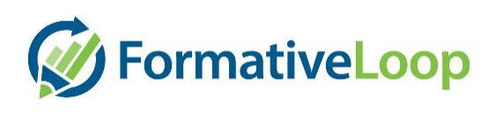

Our campus uses Formative Loop to build

your student's math foundation

Our campus uses technology to ensure your student has a solid foundation in their math skills. They are regularly practicing skills like addition, subtraction, place value, decimals, and more (grade level dependent). All essential life skills take practice, and math is no different. This program enables us to tailor that practice to your student’s individual progress. It ensures that they have mastered all the critical areas and will highlight any points to focus instructional time. You may have noticed these exercises coming home.

**Ask your student how they are doing & ask your teacher how you can help!** We look forward to watching them grow in their mathematical confidence.

Our campus uses Formative Loop to build

your student's math foundation

Our campus uses technology to ensure your student has a solid foundation in their math skills. They are regularly practicing skills like addition, subtraction, place value, decimals, and more (grade level dependent). All essential life skills take practice, and math is no different. This program enables us to tailor that practice to your student’s individual progress. It ensures that they have mastered all the critical areas and will highlight any points to focus instructional time. You may have noticed these exercises coming home.

**Ask your student how they are doing & ask your teacher how you can help!** We look forward to watching them grow in their mathematical confidence.